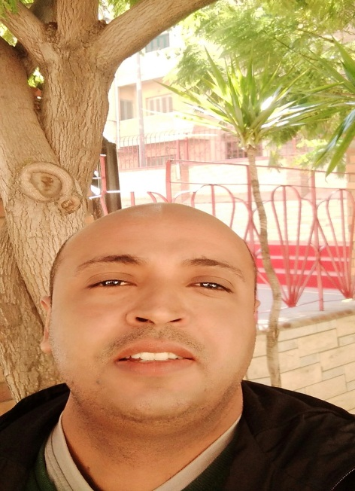

Nabil Atef Abdel Kader Abou Elinain
16 Almoteaa st. Moharam Bey-Alex
Egypt
01202764676
Alkhatab77@hotmail.com
RESUME

EDUCATION AND DEGREES
- Bachelor of Arts.Arabic department 1997-2000
Faculty of Arts,Alex University, Alex, Egypt
- Educational Diploma 2001-2002
- Faculty of Education,Alex University,Alex, Egypt
- English< >Arabic Translation Diploma 2002-2004
- Linguistique studies institute-Arts faculity,Alex University, Alex, Egypt

TRAININGS AND COURSES

- Attended English Language Course
- Ministry Of Defense language Institute - Modli Alex- April-June2002
Several courses related to the educational process, such as: 2004-present
- Using modern technological means in education
- Active learning
- quality of education
- Modern learning methods

PROFESSIONAL EXPERIENCE
- Teacher of Arabic 2001-2004
Moharam bey commerce Secondary School Alex-Egypt
Teaching Arabic language to grades 10-12 students
- Teacher of Arabic 2004 – present
Sacred heart language School
Teaching Arabic language to grades 7-11students

LEADERSHIP EXPERIENCE
- head Arabic teachers 2015 – Present
- Quality and training unit 2012 – Present
- making tests 2004 – Present

